Employee Layoffs Analysis

USING SQL

MADE BY: TEJAS AHUJA

**Introduction**

**Background**:

The dataset pertains to employee layoffs, which is a critical aspect of workforce management. Analyzing layoff data helps organizations understand the factors leading to layoffs and make informed decisions to minimize future layoffs. The data set was taken from Kaggle-a website for data analysts, scientists and machine learning enthusiasts.

**Problem Statement**:

The analysis seeks to answer the following questions: Which companies made the layoffs? How much percentage of employees were laid off from each company? How does location and stage factor into the layoff patterns? What is the relation between funds raised by a company and the number of employees laid off?

**Objectives**:

1. To identify the main companies responsible for layoffs.
2. To examine the distribution of layoffs across different countries and cities.
3. To assess any patterns related to stage and layoffs.
4. To explore the relationship between funds raised and layoffs.

**Data Collection and Description**

**Data Source**:

The dataset was provided in a CSV file named layoffs.csv, which includes records of employee layoffs. The SQL script named Employee_Layoffs_Project.sql was used for analysis.

**Data Structure**:

The dataset includes records such as Company, Location, Industry, total number of employees laid off, Laid off employees as a percentage of total employees in the company, Date of layoff, Country and funds raised by the company in millions.

**This dataset contains data on approximately 2,362 employees from various companies around the globe.**

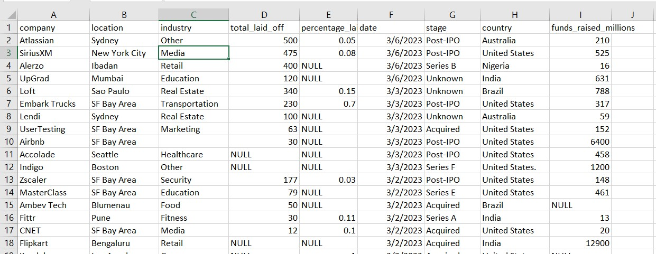

**Data processing**

**Data Cleaning:**

The SQL code performed various data cleaning steps, including removing duplicate rows, standardizing data, handling columns with null values by adding or removing data, deleting rows which were not required for analysis. No data from external sources were integrated; the analysis was based solely on the provided dataset.



* The difference between the two gives us the number of duplicate rows=5

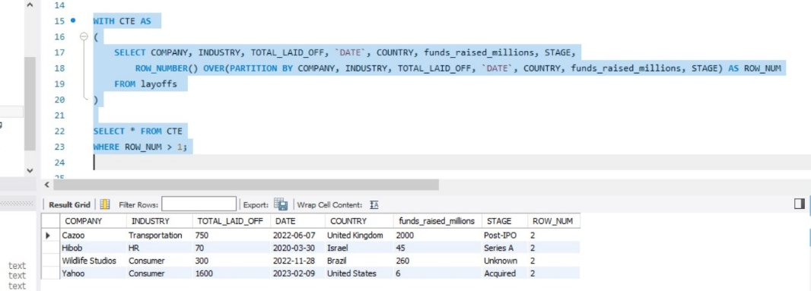

* Row number was assigned and duplicate rows were found out by using the common table expression.

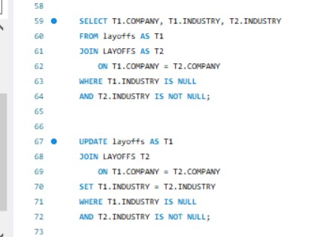

* There were some columns where the industry was not mentioned or had a null value….we joined the main table to itself and checked for data in other rows and then assigned values to the missing rows of industry column

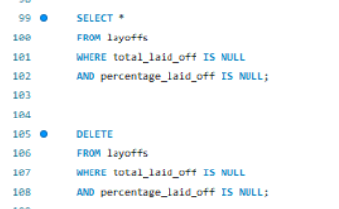

We deleted the rows which had no data of employees laid off and percentage using simple queries.

**Exploratory Data Analysis (EDA)**

**Descriptive Statistics**: The SQL code generated key descriptive statistics, such as the maximum number of laid-off employees by a single company and the distribution of layoffs across different companies and countries.

**Trends and Patterns**: The SQL code identified patterns, such as higher layoffs in specific industries or during certain time periods, which are crucial for understanding the dynamics of layoffs in any organization.

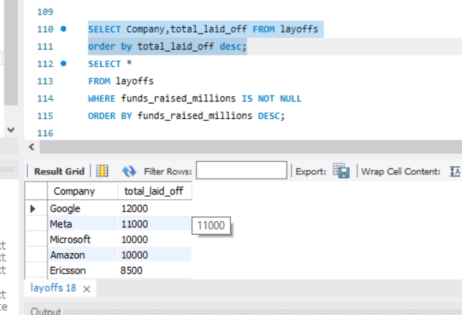

* This query shows that google as a company has fired 12000 employees on a **single day**.(maximum)

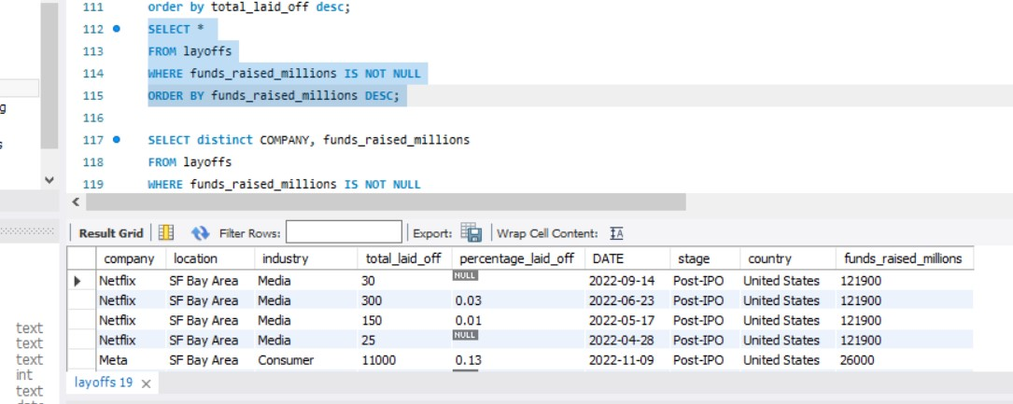

* This query shows that Netflix tops the list in fundraising. It has raised about 121.9 billion dollars.

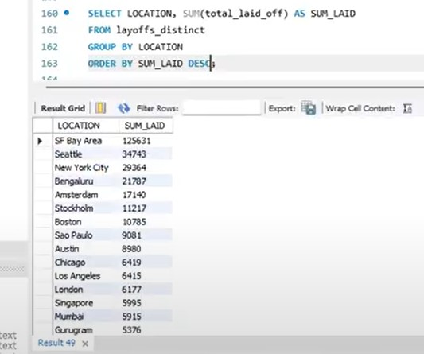

* This query shows that maximum number of layoffs took place in SF Bay Area with 125631 employees being laid off.

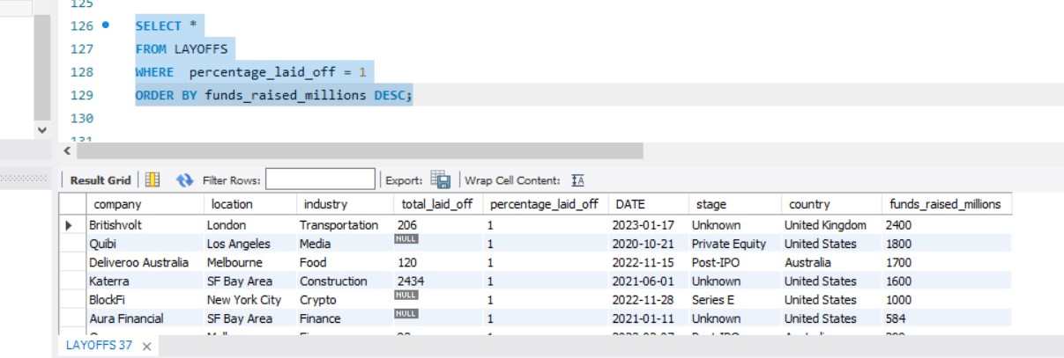

* The maximum percentage of employees being laid off as a percentage of total employees in the company is 1 percent and the company which has raised the most funds laying off 1 percent of employees is **BritishVolt.**

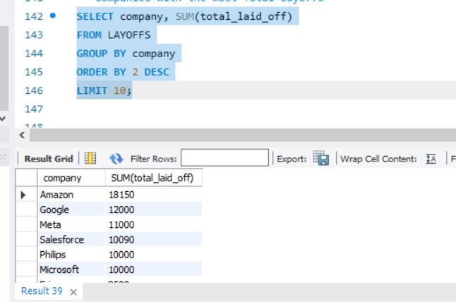

* Amazon tops the list in laying off maximum number of employees being 18150 overall.

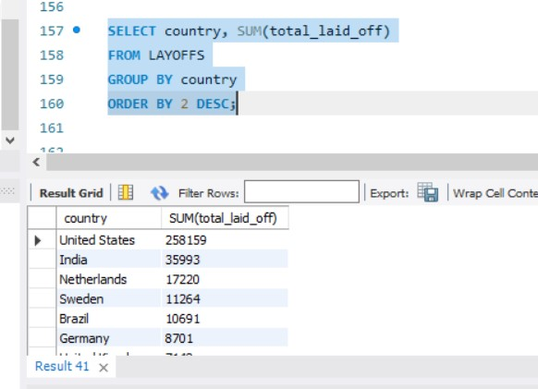

* Most number of layoffs took place in United States Of America



* Most number of Employees were laid off in the year 2023.

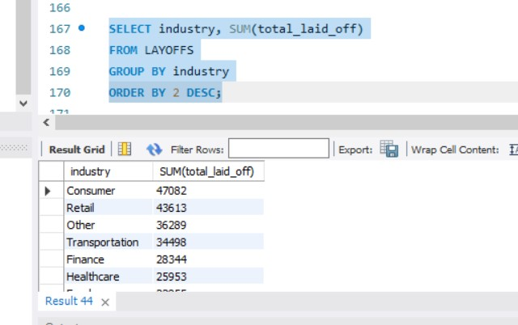

* Consumer Industry has fired maximum number of employees(47082)

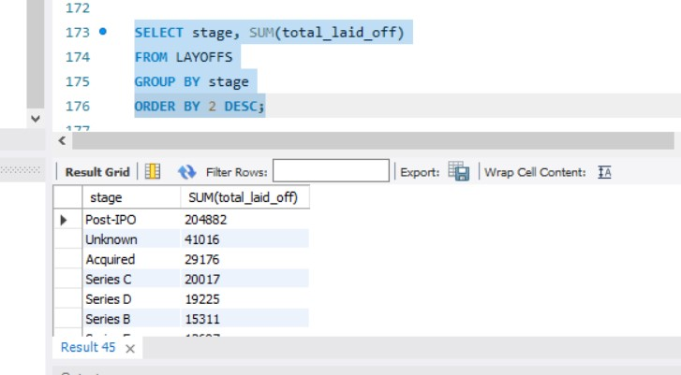

* Most number of layoffs were made by companies who are already listed and are in -post ipo stage.

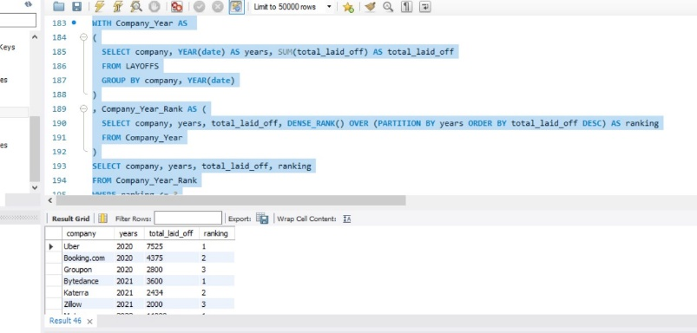

* This query ranks the top 3 companies year wise from 2020 to 2023.

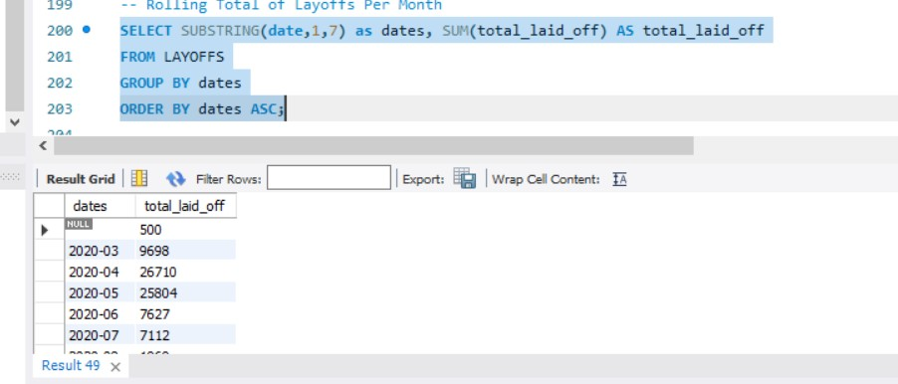

* This query gives us layoffs month wise across 3 years from 2020-23.

**KEY FINDINGS**

* Most Number of employees fired at once-**12000-Google**
* Company which has raised maximum number of funds-**Netflix(121.9 Billion USD)**
* Maximum number of layoffs took place in **SF Bay Area (California) with 125631** **employees** being laid off.
* The maximum percentage of employees being laid off as a percentage of total employees-**1 percent**
* **Britishvolt** is the company that fired 1% of its employees and raised the most funds among companies that fired 1% of their employees.
* **Amazon** tops the list in laying off maximum number of employees being 18150 overall.
* Most number of layoffs took place in **United States Of America**
* Most number of Employees were laid off in the year **2023.**
* Consumer Industry has fired maximum number of **employees-47082**
* Most number of layoffs were made by companies who are already **listed and are in -post ipo stage**

|  |  |  |  |
| --- | --- | --- | --- |
| **YEAR** | **Highest Number of Layoffs** | **Second Highest Number of Layoffs** | **Third Highest Number of Layoffs** |
| **2020** | Uber-7525 | Booking.com-4375 | Groupon-2800 |
| **2021** | Bytedance-3600 | Katerra-2434 | Zillow-2000 |
| **2022** | Meta-11000 | Amazon-10150 | Cisco-4100 |
| **2023** | Google-12000 | Microsoft-10000 | Ericsson-8500 |

**CONCLUSION**

Summary:

The SQL code provided a comprehensive analysis of employee layoff data, highlighting key trends and areas of concern. The findings can inform strategic decisions for more job opportunities.

Implications:

The analysis underscores the importance of continuous monitoring of workforce dynamics and the need for proactive measures to address factors leading to layoffs.